Wildcards 2.0
Use case scenarios

- Therapist experience
Luisa is a therapist who wants to study how the attention of her little patient Luigi can be stimulated in different ways and in which situations he tends to be more focused.
First, the therapist welcomes the child into the room and seats him comfortably in a (swivel?) chair.
Luisa starts talking to Luigi to make him as comfortable as possible.
The therapist explains to the child about the novelty of the day: today Luigi will wear a visor that will allow him to enter the world of the characters from the stories that the child already knows. Luisa presents the visor to the child so that he can become more familiar with the device. The therapist only has to configure the visor.
First, she turns on the device ,she will also have to activate the external terminal and configure it ,to be able to see in real time the activity carried out by the child during the session . Now she must put on the visor and choose the experience for the child.
Now everything is ready, the therapist removes the visor and makes the child put it on, Luisa then starts by presenting the chosen game to Luigi:
-Research 360: the therapist explains to the child that to proceed he will have to find the object pointed by the arrow to proceed in the level and reach the goal
-Story 360: the therapist explains to the child that in order to proceed he/she will have to point at the protagonist of the story to make the narration proceed
-Exploration: the therapist explains to the child that to reach the end of the maze he/she will have to point at characters at the end of each corridor.
The child can then begin the play experience following the therapist's instructions.
At the same time Luisa can observe the child's behaviour during the experience,
Once the play session is over and the objective of the game has been achieved, the therapist will take the visor away from the child and say goodbye to him, inviting him to leave the room.
Luisa will now be ready to analyse the data that was recorded during the experience.

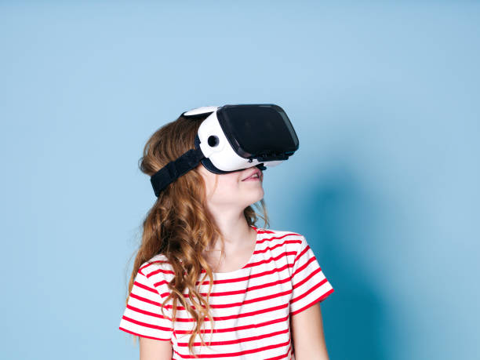
- Child experience
Lucrezia is a child with NDD which is going to do a session with her therapist Luca.
The girl enters her therapist's room, sits in a comfortable chair, and listens to what the therapist wants to tell her.
She lets Luca put the visor on her so that she can start the play session.
Depending on the choice the therapist has previously made, the child will find herself thrown into a different story with different objectives:
-Research 360: the child will be projected into an open 3D environment in which he or she will have to point with the controller at various indicated objects in order to advance the game.
- The child puts herself in the shoes of Suzy, a little animal in a snowy landscape. Lucrezia will have to find the objects to build a snowman.
First, she will go in search of a snowball, then she will look for wooden twigs to build the arms of the snowman. Next she will go in search of a hat and a carrot to create her new friend's nose. To finish his creation he will go in search of stones to create buttons. As a last item, all she has to do is look for a camera to take a picture with her new friend.
- If the child steps into Tobia's shoes he will find himself in a deserted landscape. Tobia decides to take a walk in the desert to go in search of the famous pyramid of Keops. The child will start his game by searching a palm tree and then find a camel to make friends with. As a third object to find there will be a well and then a prickly cacatus. The goal of the game will be reached when the child has found the pyramid.
- The child will step into Tullio's shoes, immersing himself completely in a campsite. In order to continue the game, he will first have to go in search of a backpack, then a sleeping bag and a lamp. As the last two items in order to finish the game he will have to go for a fire and a tent.
- The little girl will step into Laura's shoes by being catapulted into a beautiful playground. The girl will have to go in search of a slide first, and then go in search of a swing and a ball. As the last two objects to conclude the play experience she will have to search for a radio and a new swing.
on which she wants to have fun is the slide
- The child will put himself in the shoes of Bendy who is in a house and wants to start tidying it up. He will first look for a broom and then look for some T-shirts to put in order. Next, he will have to go in search of a bucket and water to wash the floor. As the last item in the search there will be a rucksack
- Story 360: the child will be projected into an open 3D environment in which he/she will have to point with the controller at an object in order to advance the story.
- The little girl puts herself in suzy's shoes by immersing herself in a seascape. In order to start the story, the little girl will have to point at suzy, who will search for the first object: a parasol.
The next objects to be searched for to continue the story are, in order, a deckchair and a ball. Now all that remains for her to do is to search for a playmate. She will then go in search of a crab and a seagull.
- The child will take the place of Tullio, a rabbit who lives on a large farm full of animals. Tullio wants to celebrate his birthday so he will go in search of the various animals living on the farm to invite them to his party. The child will point at Tullio and make him move to begin the search for his friends. First he will meet the piglet, then he will find his friend the cow and his great friend the horse. The last two animals to be invited are the sheep, the dog and the llama.
- The little girl enters the role of Tobia. The protagonist in a kitchen wants to prepare an apple pie for mom’s birthday. The little girl pointing the protagonist will allow Tobia to begin the search for the sheet on which the recipe is written. Then he will have to look for the bowl, Now he can start the search for ingredients , an apple, eggs and milk
- The little girl enters the role of Laura a kitten who wants to form a musical band and goes in search of the best musical instruments. The kitten being pointed at by the little girl begins the search for her first instrument: the piano. Then to be added to the band will be a chiatrra, a saxophone and a trumpet.As last essential instruments there will be a drum and a violin.
- The baby will take on the role of Bendy, an alien just arrived on Mars.
Bendy will begin the exploration of the new planet only when he is aimed at the child. As the first object he will find a spaceship and an alien. The next objects that will be achieved will be a radio and a scooter. Finally, as the last object there will be a spaceship to return home.
- Exploration: the child will be projected into a 3D environment simulating a maze in which he/she will have to point at boxes to proceed inside it.
Once the experience is over, the child ends the session

Terapista
  - Accoglie il bambino
  - Parla col bambino
  - Introduce il dispositivo e al bambino
  - Configura il dispositivo
    - Accende il visore
    - Attiva terminale esterno (e.g. PC)
    - Configura terminale esterno per monitorare l’attività
    - Potrà osservare in streaming cosa fa il bambino e settare dei parametri per l’esperienza (e.g. l’altezza nel mondo virtuale)
    - Sceglie l’esperienza da far svolgere al bambino mettendosi il visore
    - Dopo aver scelto l’esperienza fa indossare il visore al bambino
  - Introduce il gioco
    - Research 360: il terapista spiega al bambino che per procedere dovrà trovare l’oggetto indicato per procedere nel livello
    - Story 360: il terapista spiega al bambino che per procedere dovrà puntare il protagonista della storia per far procedere il livello
    - Exploration: il terapista spiega al bambino che per raggiungere la fine del labirinto dovrà puntare le immagini appese al muro
  - Osserva in diretta il comportamento del bambino da terminale
  - Guida il bambino durante il gioco
  - Al termine del gioco toglie il visore
  - Termina la sessione con il bambino
  - Analizza i dati registrati durante l’esperienza

Bambino
  - Entra nello studio accolto dal terapista
  - Si accomoda
  - Ascolta il terapista
  - Lascia che il terapista gli faccia indossare il visore
  - Comincia la sua esperienza di gioco guidato dal terapista (assumendo che il bambino giochi da seduto)
    - Research 360: il bambino sarà proiettato in un ambiente 3D aperto in cui dovrà puntare con il controller diversi oggetti indicati per poter far procedere il gioco.
    - Story 360: il bambino sarà proiettato in un ambiente 3D aperto in cui dovrà puntare con il controller un oggetto per far procedere la storia.
    - Exploration: il bambino sarà proiettato in un ambiente 3D che simula un labirinto in cui dovrà puntare dei riquadri per procedere al suo interno.
  - Finita l’esperienza, il bambino termina la sessione

